IOT BASED ACCIDENT IDENTIFICATION AND ALERTING SYSTEM

**Abstract**:

Now a day, a major part of the accident is due to the uneven interruptions. Speed is one of the reasons for most of vehicle accidents. Hope this project will provide the solution for this drawback. If emergency services get the accident information in time, then many lives could have been saved. If a vehicle meets with an accident, the accelerometer and ultrasonic sensor detect the signal and sent it to the Arduino. The project is helpful in detecting the accident and alerting the near-by help centre by tracking the geographic location. In future, we can enhance the project by capturing the accident images using wireless webcam.

**Keywords**:

Arduino, Ultrasonic sensor, Accelerometer.

**Introduction**:

According to the survey in 2017, approximately the total of 2,076 people died in road accidents. The demand of the automobiles has increased the road accidents. Due to the lack of emergency facilities in our country, we are introducing the automatic alert device for vehicle accidents. The proposed system detects the accident and sends the information in less time to near-by first aid centre. The road accident in many developing countries is characterized by human powered vehicle without adopting traffic segregation resources. This caused great concern to engineers and planners. The road accidents are predicted to cause the leading death unless action is taken. ‘Accidents are caused not natural’, so approximate measures are developed. The uncontrolled event of a person results in personal injury. The highest percentage of all deaths due to road traffic accidents. It not only affects the crash but also increases the risk involved in it .With this project, an app is created along with the hardware components so that the information is transferred to the near-by police station or ambulance. An IOT is the network of the physical device, vehicles and other items embedded with electronics, software, sensors, actuators and network connectivity which help in connectivity of data. IOT refers to rapidly growing network of connected objects that are able to collect and exchange data using embedded sensors. It is used for monitoring events and changed in structural conditions which compresses of risk and scheduling repair and maintenance activity in efficient manner.

Components:

* Ultrasonic Sensor(HC-SR04).
* Accelerometer Sensor.
* Arduino UNO
* LCD Display(16x2).
* Buzzer, Piezo
* GPRS.
* 5mm LED(RED).
* L293-D dual bridge dc motor driver.
* Bread Board.
* Dc Motor.
* 9v Battery.

Hardware Description:

**Ultrasonic Sensor:**

Ultrasonic sensors similar to radar or sonar. It generates high frequency sound waves and evaluates the echo which is received back by the sensor. Then it calculates the time interval between sending the signal and receiving the echo to determine the distance to an object. The ultrasonic range, above 20,000 hertz, turning electrical energy into sound, while receiving the echo turn the sound waves into electrical energy.

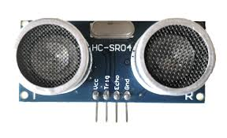

**Accelerometer Sensor:**

An accelerometer that measures proper acceleration, which is related to free fall. Single and multi-axis models are available to detect magnitude and direction of the acceleration and it used to sense the acceleration, vibration shock, and falling. Micro machined accelerometers are present in portable electronic devices to detect the position of the device.

**ARDUINO UNO:**

Arduino Uno is a microcontroller board based on the ATmega328P. It has 14 digital input/output pins, a 16 MHz quartz crystal, a USB connection, a power jack, an ICSP header and a reset button. Simply connect it to a computer with a USB cable or power it with a AC-to-DC adapter or battery to get started. A typical ARDUINO UNO board can be used for many applications based on the coded program.

**LCD Display**: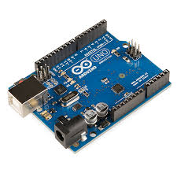

A liquid-crystal display (LCD) is a flat panel display. Liquid crystals usually do not emit the light signal directly, instead using a backlight or reflector to produce images in colour or monochrome. LCDs are available to display arbitrary or fixed images with low information content, which can be displayed, as in a digital clock

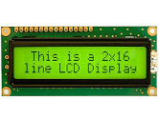

**GPRS:**

General Packet Radio Service (GPRS) is a packet oriented mobile data service on the 2G and 3G system's global system for mobile communications (GSM). In 2G systems, GPRS provides data rates of 56–114 Kbit/second. 2G cellular technology combined with GPRS is sometimes described as 2.5G, which is between the second (2G) and third (3G) generations of mobile telephony. It provides moderate-speed data transfer, by using unused time division multiple access (TDMA) channels.

**BLOCK DIAGRAM:**

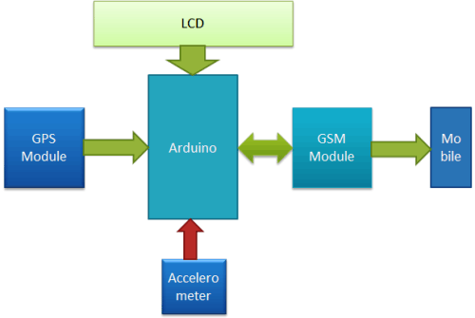

**Working Procedure:**

The block diagram consists of accelerometer sensor, ultrasonic sensor, Arduino UNO, U slot sensor, LCD display, GPRS, interfacing circuit, potentiometer and System Control Unit (SCU). A potentiometer is a three terminal resistor with a sliding contact that forms an adjustable voltage divider. It is used to control significant power, since the power dissipated in the potentiometer would be comparable to the power in the controlled load. The potentiometer is connected with control circuit to control the power. A 12v tape motor is connected along with the control circuit. It operates at 12v and 2A of current. It is used for the purpose of high speed and very less requirement of torque. An Ultrasonic sensor is connected with Arduino UNO to send the signal. Ultrasonic sensor generates high frequency sound waves at regular time intervals. These propagate at the velocity of sound in the air. They are reflected back as echo signals to the sensor if they strike an obstruct. This reflected echo signals to decrease the vehicle speed. The ultrasonic sensor has an ultrasonic transmitter and ultrasonic receiver with one oscillator and it generate a 4 kHz ultrasonic sound that allows you to measure distances up to 2 meters. Ultrasonic transmitter converts the electrical signal into ultrasounds and the ultrasonic receiver convert the ultrasounds into electrical signal and then transmit the signal to Arduino UNO through interfacing circuit. An accelerometer sensor which is a device that measures the proper acceleration, that acceleration experienced relative to free fall. Accelerometer sensor detects the sudden changes in the axes of the vehicle. If the speed of the vehicle increases above the limited level, then it will send the signal to Arduino UNO. An interfacing circuit is connected between accelerometer sensor and Arduino to transfer the signal. A U slot sensor is normally used as positional sensor switch to find the position of the wheel. If the condition of the vehicle goes abnormal then it will send the signal along with the position of vehicle to Arduino UNO, which is passed through interfacing circuit. An LCD display is connected with Arduino UNO to display the message if any defect occurs in the vehicle. An Arduino UNO is connected with GPRS (General Packet Radio Device), which is a packet oriented mobile data service on the 2G and 3G cellular communication system’s global system for mobile communication. It is used to transfer the data to nearby police station or ambulance along with location of vehicle.

When the accident occurs, the accelerometer senses the acceleration and sends a signal to the Arduino. Then it will send an alert message to the predefined number. Then the LCD screen will show a message as message sent.

**Connection Diagram:**

**Accident Detection:**

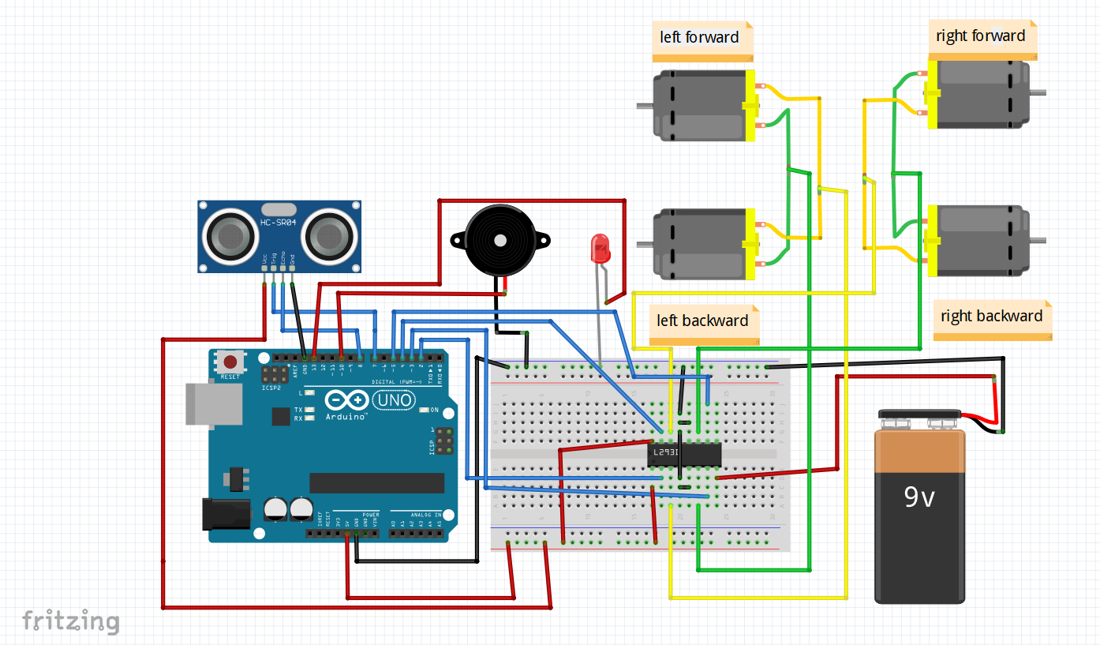

**Accident Protection:**

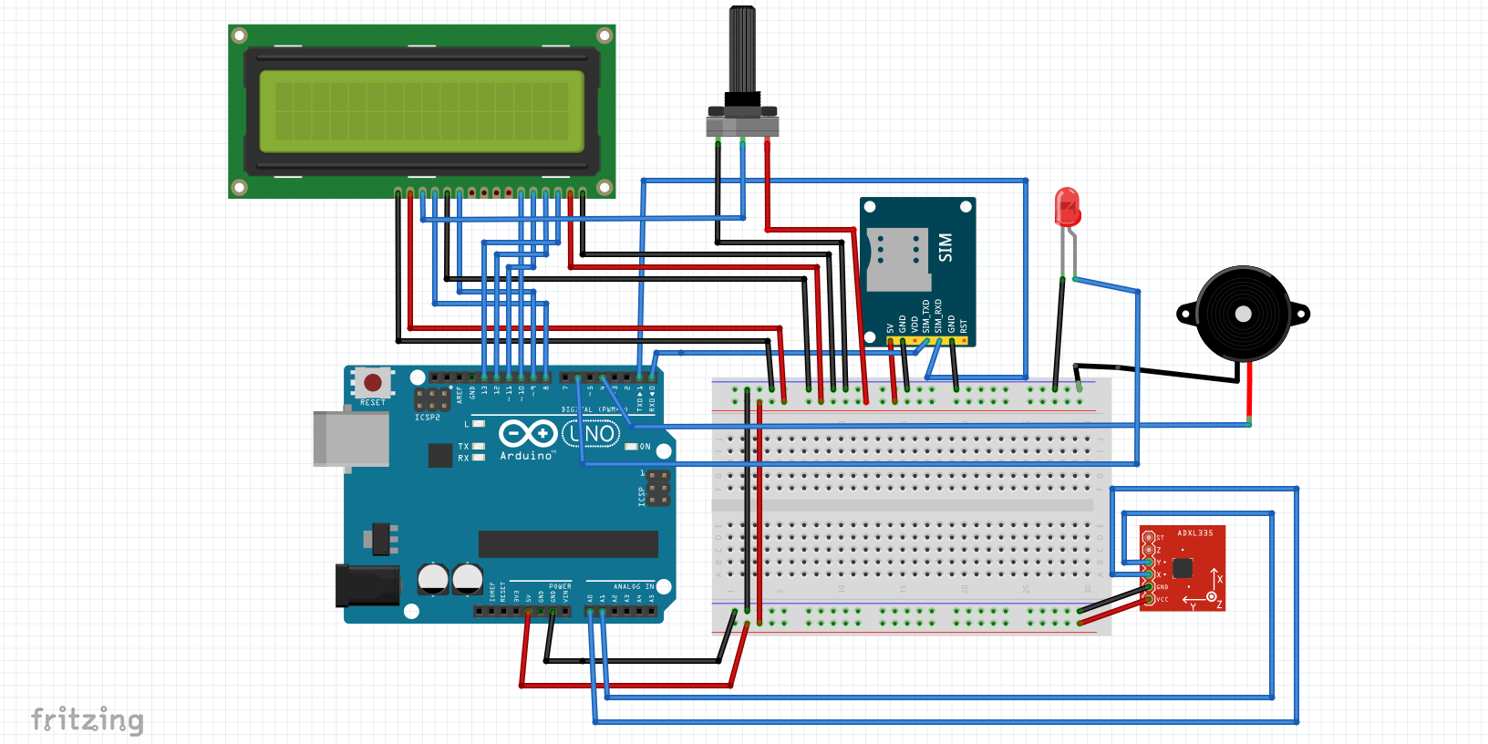

OUTPUT:

